# V_CALL ANDROID APPLICATION

**By**

**PRAJWAL B S**

### Under Supervision Of

**Mr. Aravind R&D ENGINEER**

**EXPOSYS DATA LABS**

### To

**EXPOSYS DATA LABS**



### CERTIFICATE

**Candidate’s Declaration**

I hereby declare that the work presented in this report entitled **“V_Call Application”** in almost complete of the requirements for one month internship submitted to the Exposys Data Labs Limited is an authentic record of my own work carried out over a period from 11th February 2022 to 11th March 2022 under the supervision of **Mr. Aravind, R&D Engineer, Exposys Data Labs.**

The matter embodied in the report has not been submitted for the award of any other degree or diploma.

(Student Signature)

#### Prajwal B S

This is to certify that the above statement made by the candidate is true to the best of my knowledge.

(Supervisor Signature)

#### Mr. Aravind R&D Engineer

**Exposys Data Labs Date: 11 -03 -2022**

### ACKNOWLEDGEMENT

We would like to express our special thanks of gratitude to our supervisor **Mr. ARAVIND R&D ENGINEER EXPOSYS DATA LABS** who gave us the golden opportunity to do this wonderful project on Android Applications, which also helped us in doing a lot of research and we came to know about so many new things about android. We are really thankful to Exposys Data Labs for creating this wonderful opportunity to explore our potential in Software development.

Name Of The Student

Date: 11-03-2022 Prajwal B S

Table Of Contents

|  |  |  |
| --- | --- | --- |
| S.NO | Title | Page No |
| 1 | Abstract | 02 |
| 2 | Architecture | 03 |
| 3 | Software Development Kit | 04 |
| 4 | Objective and Methodology | 05 |
| 5 | Implementation | 06 |
| 6 | Snap Shot | 07 |
| 7 | Conclusion and References | 10 |

### ABSTRACT

With the advent of new mobile technologies, the mobile application industry is advancing rapidly. Consisting of several operating systems like Symbian OS, iOS, blackberry, etc., Android OS is recognized as the most widely used, popular and user-friendly mobile platform. This open-source Linux kernel-based operating system offers high flexibility due to its customization properties making it a dominant mobile operating system. Android applications are programmed in java language. Google android SDK delivers a special software stack that provides developers an easy platform to develop android applications. Moreover, developers can make use of existing java IDEs which provides flexibility to the developers. Java libraries are predominant in the process of third-party application development. Cross-platform approaches make sure that developers do not have to develop platform-dependent applications. With the help of these approaches, an application can be deployed to several platforms without the need for changes in coding. However, android is more prone to security vulnerabilities which the majority of the users do not take into account. Any android developer can upload their application on the android market which can cause a security threat to any android device.

So our aim is to develop an android application to give information about the details of People who are interested in the sports, in this application user can add their interested sports while building their profile. Also user can update their profile whenever they need.

## Android

Android is a [mobile operating system](https://en.wikipedia.org/wiki/Mobile_operating_system) (OS) currently developed by [Google,](https://en.wikipedia.org/wiki/Google) based on the [Linux kernel](https://en.wikipedia.org/wiki/Linux_kernel) and designed primarily for [touchscreen](https://en.wikipedia.org/wiki/Touchscreen) mobile devices such as [smartphones](https://en.wikipedia.org/wiki/Smartphone) and [tablets.](https://en.wikipedia.org/wiki/Tablet_computer) Android's [user interface](https://en.wikipedia.org/wiki/User_interface) is mainly based on [direct manipulation](https://en.wikipedia.org/wiki/Direct_manipulation_interface), using touch gestures that loosely correspond to real-world actions, such as swiping, tapping and pinching, to manipulate on-screenobjects, along with a [virtual keyboard](https://en.wikipedia.org/wiki/Virtual_keyboard) for text input. In addition to touchscreen devices, Google has further developed [Android TV](https://en.wikipedia.org/wiki/Android_TV) for televisions, [Android Auto](https://en.wikipedia.org/wiki/Android_Auto) for cars, and [Android Wear](https://en.wikipedia.org/wiki/Android_Wear) for wrist watches, each with a specialized user interface. Variants of Android are also used on [notebooks](https://en.wikipedia.org/wiki/Laptop), [game consoles](https://en.wikipedia.org/wiki/Video_game_console), [digital](https://en.wikipedia.org/wiki/Digital_camera) [cameras,](https://en.wikipedia.org/wiki/Digital_camera) and other electronics.



# Architecture

Login

Through Mobile Email and Password

FALSE

Verifies Email and Password Of The User

T R U E

Take To Main Page

(Enter Secret code and Join The Meeting)

End

END

They Can chat through that video conference.

### Software Development Kit

A software development kit (SDK) is typically a set of [software development](https://en.wikipedia.org/wiki/Software_development) tools that allows the creation of [applications](https://en.wikipedia.org/wiki/Application_software) for a certain [software](https://en.wikipedia.org/wiki/Software) package, [software framework,](https://en.wikipedia.org/wiki/Software_framework) hardware platform, [computer system,](https://en.wikipedia.org/wiki/Computer_system) [video game console,](https://en.wikipedia.org/wiki/Video_game_console) [operating system](https://en.wikipedia.org/wiki/Operating_system), or similar development platform. To create applications, you have to download this software development kit. For example, if you want to create an Android app you require an SDK with java programming, for iOS apps you require an iOS SDK with swift language, and to develop MS Windows apps you require the.net language. There are also SDKs that are installed in apps to provide analytics and data about activity. Prominent examples include [Google](https://en.wikipedia.org/wiki/Google) and [Facebook.](https://en.wikipedia.org/wiki/Facebook)

Software development toolkits allow developers to add functionality to their applications and enable them to build the standard components of their apps easier and faster. SDKs are usually all-in-one products and don’t need to be integrated with other components, which can slow down the development process.

Typically, developers use SDKs for simple functions, such logging in, location services and mobile payments. However, there are also SDKs that help developers build more complex app features, such as augmented reality ([AR](https://whatis.techtarget.com/definition/augmented-reality-AR)) and virtual reality (VR). SDKs reduce complex integrations by simplifying standard processes, such as creating authorization signatures or interpreting SMS messages in native languages or platforms.

### Android Studio

Android Studio is an [integrated development environment](https://en.wikipedia.org/wiki/Integrated_development_environment) (IDE) for developing for the [Android](https://en.wikipedia.org/wiki/Android_(operating_system)) platform. It was announced on May 16, 2013 at the [Google I/O](https://en.wikipedia.org/wiki/Google_I/O) conference. AndroidStudio is freely available under the [Apache License 2.0.](https://en.wikipedia.org/wiki/Apache_License) Android Studio was in early access preview stage starting from version 0.1 in May 2013, then entered beta stage starting from version 0.8 which was released in June 2014. The first stable build was released in December 2014, startingfrom version 1.0. Based on [JetBrains' IntelliJ IDEA](https://en.wikipedia.org/wiki/JetBrains) software, Android Studio is designed specifically for Android development. It is available for download on [Windows](https://en.wikipedia.org/wiki/Windows), [Mac OSX](https://en.wikipedia.org/wiki/Mac_OS_X) and [Linux](https://en.wikipedia.org/wiki/Linux), and replaced [Eclipse](https://en.wikipedia.org/wiki/Eclipse_(software)#Eclipse_ADT_.28Android_Development_Tools.29) [Android Development Tools](https://en.wikipedia.org/wiki/Eclipse_(software)#Eclipse_ADT_.28Android_Development_Tools.29) (ADT) as Google's primary IDE for native Android application development.

### Problem Statement:

To develop V_Call application to give information about user like email, name and password. This application will allow all users to enter secret code and start the video meeting and can share the secret code via social media to their friends and colleagues. User can access this application anywhere and anytime with internet connection using phone.

### Objective

There are 5 objectives in this project:

1. To setup Android software development kit.
2. To write a program that can do various tasks such as running media, displaying information, sending notifications multi-tasking.
3. Handling the verification of user entered email id and password.
4. Adding secret code and join video call.
5. Share with friends and colleagues and chat with them.

**Methodology**

This project is made by using Android studio. The programming languages used for building the application are Java and XML.

User interface is handled using XML codes. Backend programming is handled mainly through set of java codes. Firebase database used to store the user data.

The other libraries required are:

* + Android SDK tools
  + Android SDK platform tools
  + Android SDK build tools
  + SDK platform

## Implementation

In this application I used xml for user interface and design and java for programming to build the logic.

In this app first we have to register ourself by giving our name, email id and password, it’ll verify like whether the email id existing in database if it exists then it’ll give an error message like user existed with this email id.

Once registration Success it’ll redirect to login page and you have to login with email id and password, and it’ll redirect you to main page where You can enter secret code and join the video meeting.

On the Successful of that the it’ll ask for camera and mic permission for chatting purpose, you can also chat in this platform can also send emoji.

Snap Shot

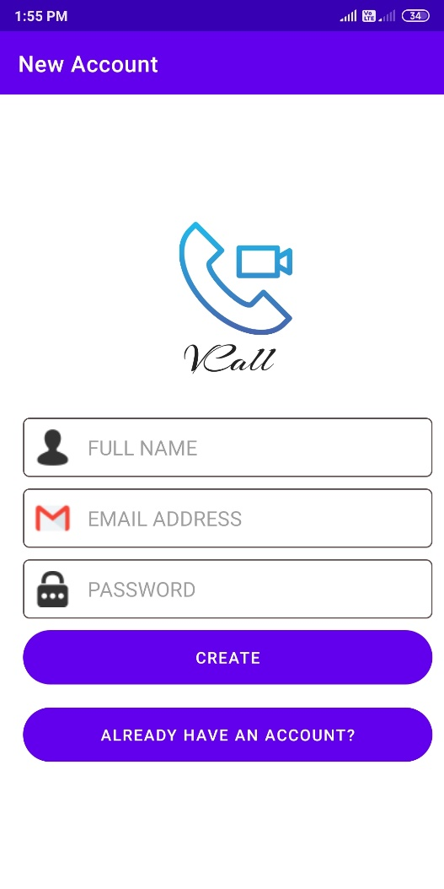

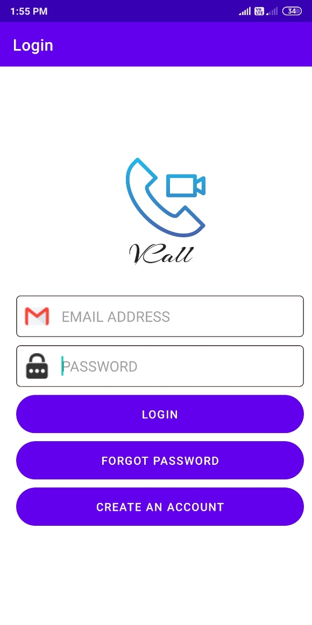

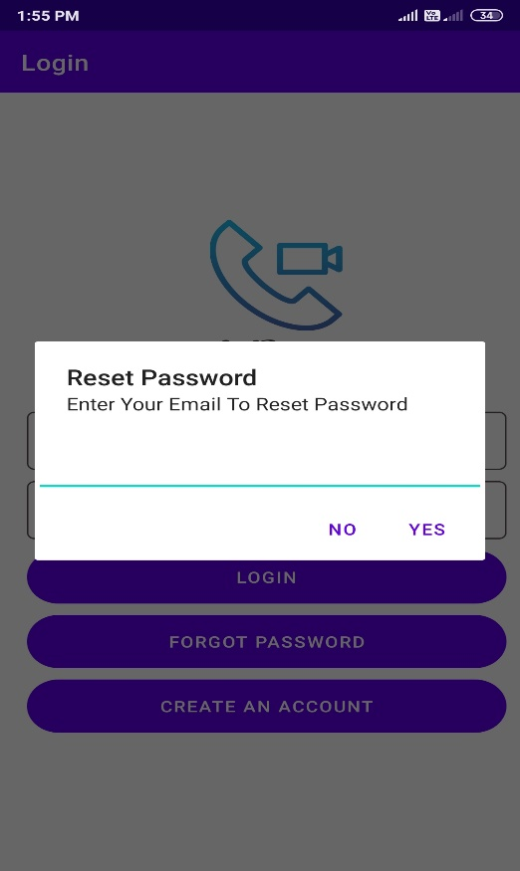

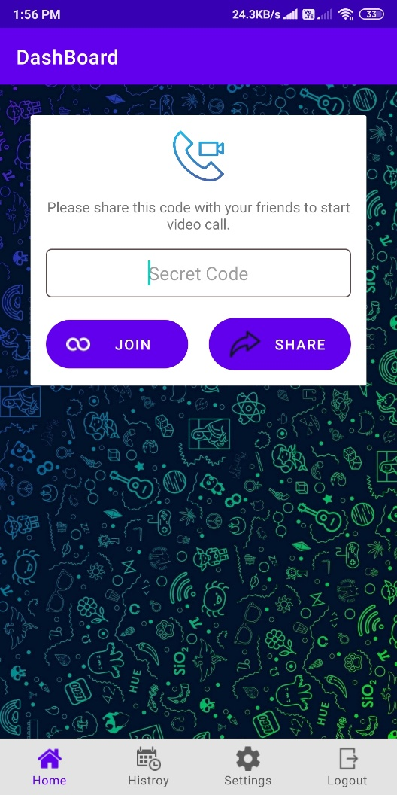

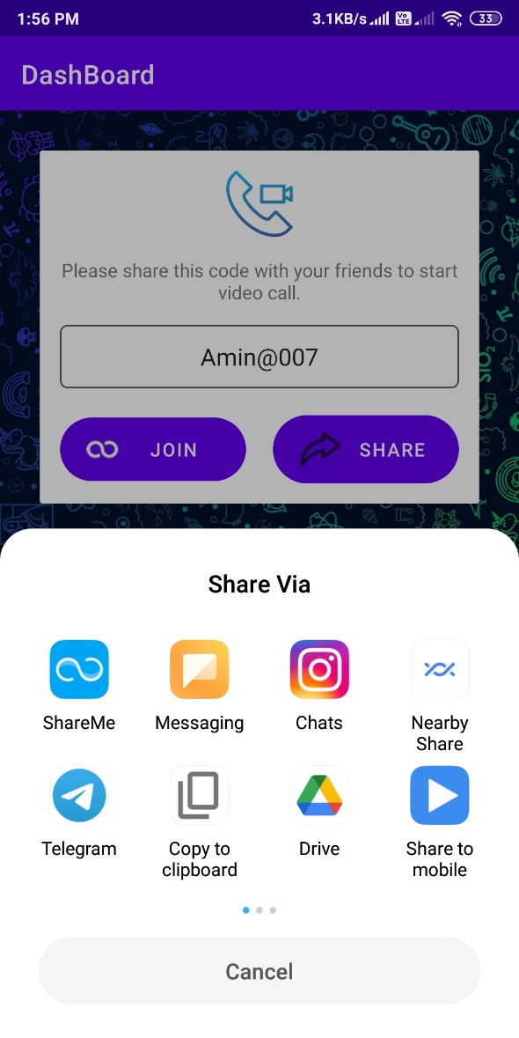

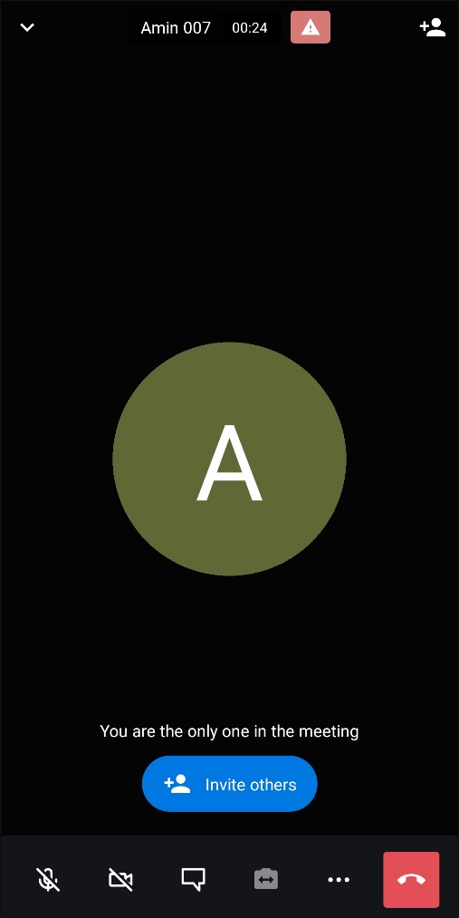

### Conclusion

Android as a full, open and free mobile device platform, with its powerful function and good user experience rapidly developed into the most popular mobile operating system. This report gives an overview of the different challenges and issues faced in android app development The experience of developing an android app is quite challenging, motivating as well as satisfying.

### References:

* [www.youtube.com](http://www.youtube.com/)
* [www.google.com](http://www.google.com/)
* [www.stackoverflow.com](http://www.stackoverflow.com)
* https://ieeexplore.ieee.org/